Week 6

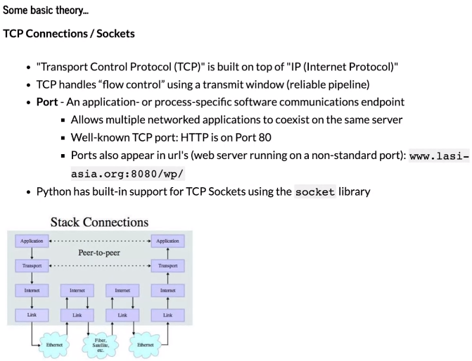

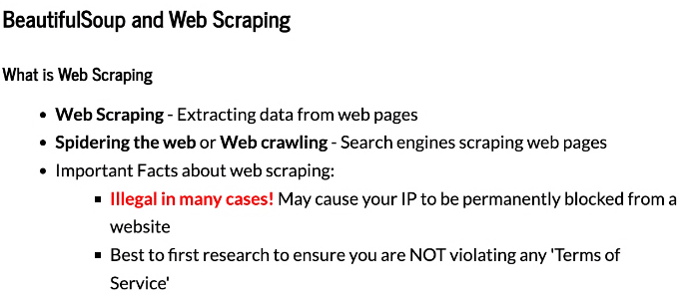JSON is one of the most commonly used formats for sending data across the net

Gather – asking too many questions is better than too few; establish what your input and output is supposed to be; find edge cases(); write out requirements; establish programming languages and expected structure ie functions, loops, etc; the goal is to clarify the problem to the point that there are no more questions

Breakdown – restate the key points; establish the priorities of the problem

Pseudocode – don’t write any code just what you expect; focus on structure; just use plain English as if explaining to a child

Write a solution – start writing code; talk with your interviewer while coding, think outloud; mistakes are okay; syntax errors are not the end of the world; be sure to write neatly so your code can be read

Test – walk through the steps of your code verbally; test edge cases meaning what could go wrong with the data types you use in your code

Consider changes – review and fix any bugs, discuss ways to improve